CS 255 System Design Document
Jessica Johnson
02/22/2025
SNHU CS 255

UML Diagrams

UML Use Case Diagram
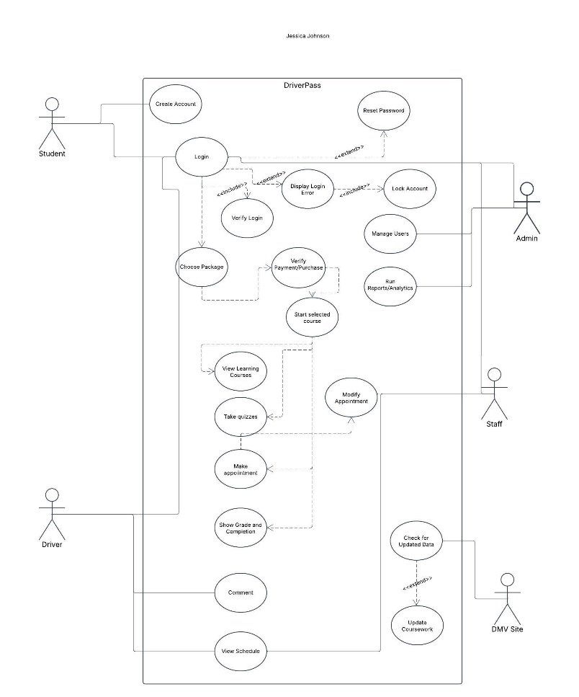

UML Activity Diagrams
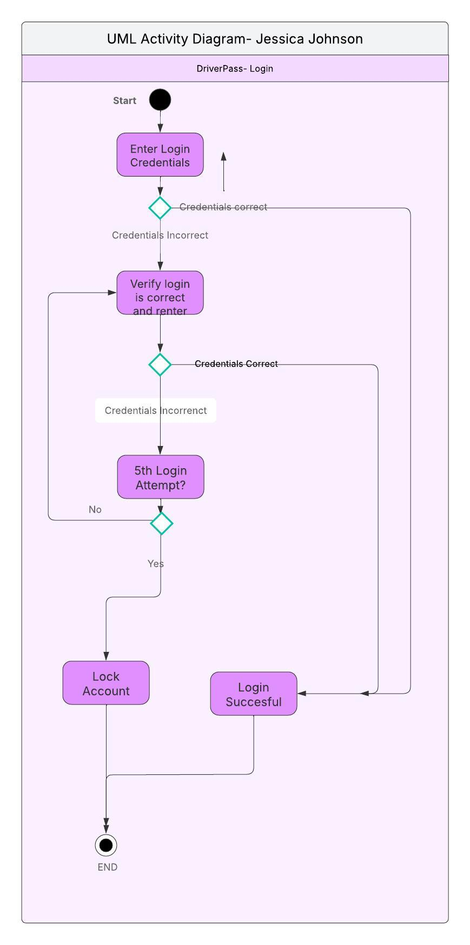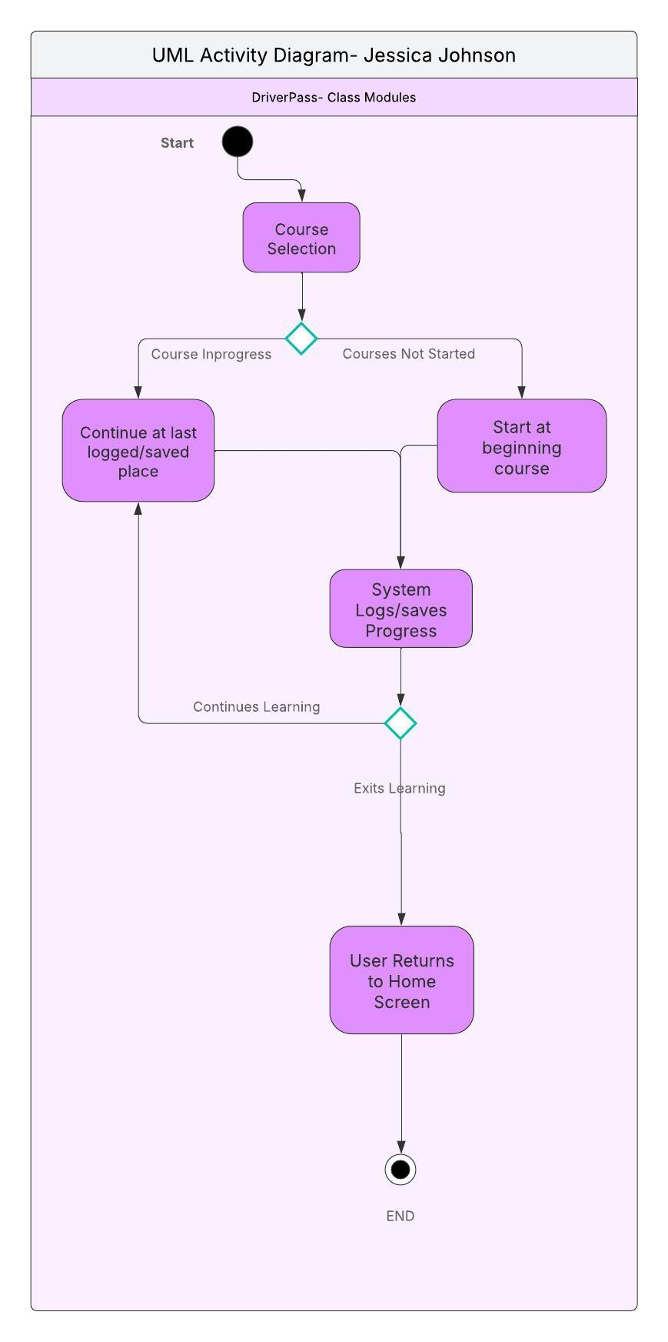

UML Sequence Diagram
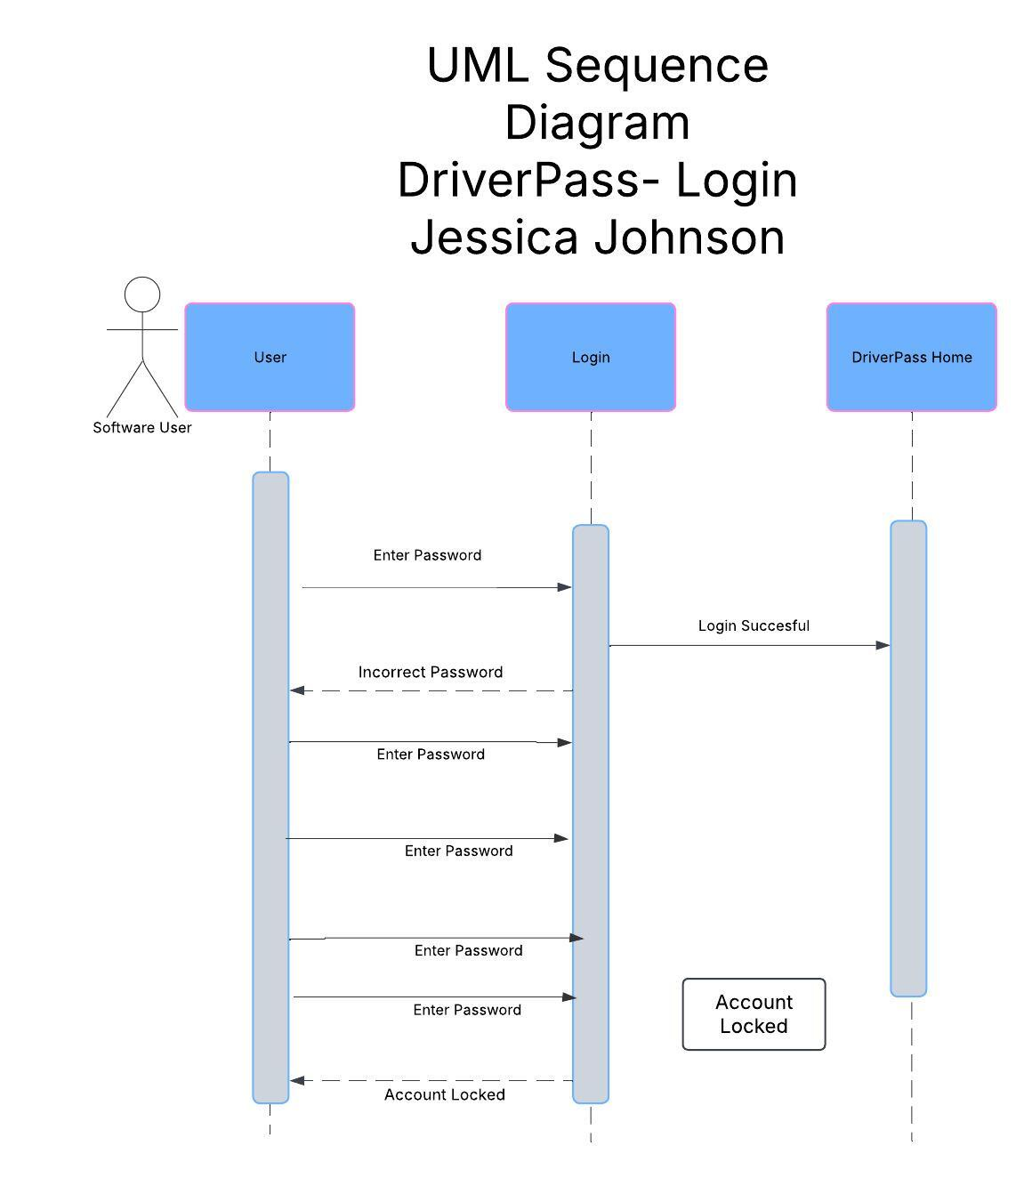

UML Class Diagram
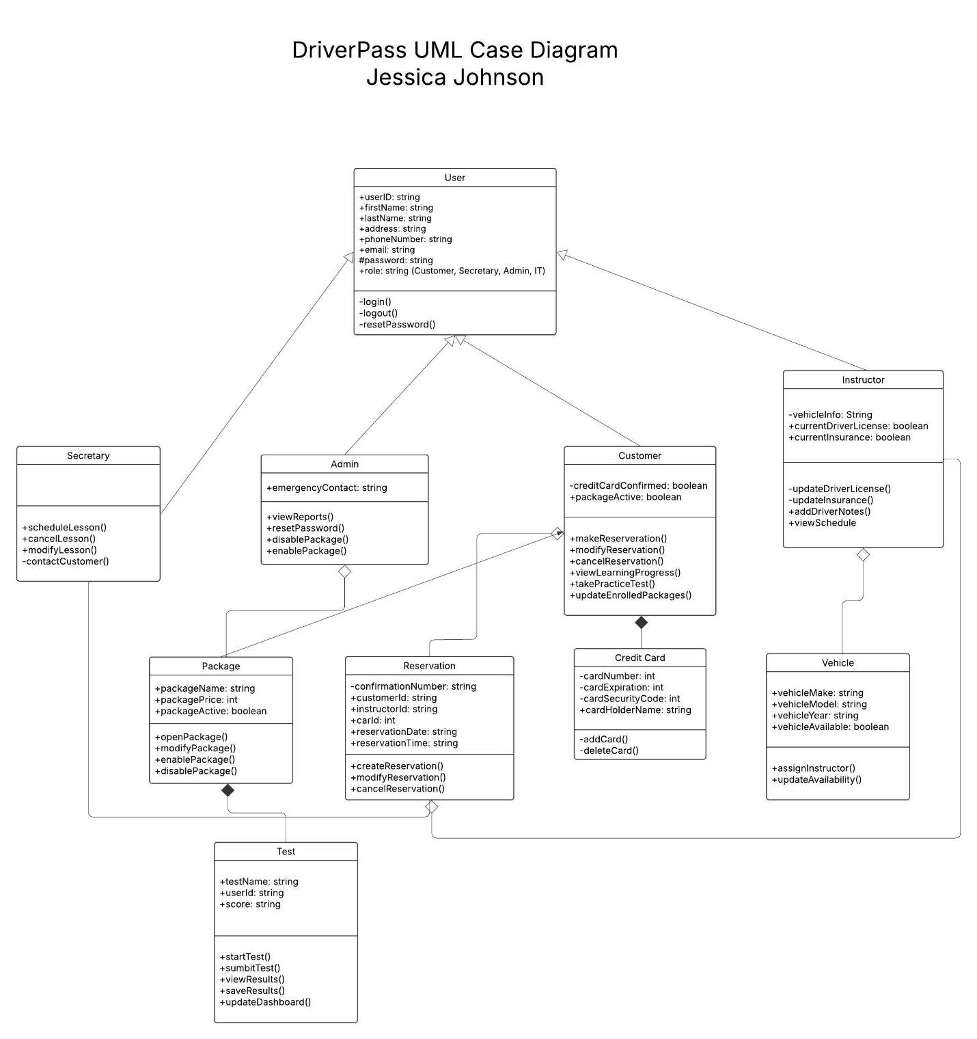

Technical Requirements

Our online-based learning system, DriverPass, has technical requirements. Here’s a few we can start with:
Hardware: Computer, Internet connection, physical server
Software: Server, databases, security systems to keep intruders out, web browser like Firefox or Chrome
Tools: IDEs like Microsoft Visual Studio or Eclipse
Infrastructure: The system should be on a cloud platform to ensure reliability and scalability.

References

[Lucid Software]. (2018, February 7). UML Use Case Diagram Tutorial [Video]. YouTube. https://www.youtube.com/watch?v=zid-MVo7M-E

